CO2 CASE STUDIES
ON
UNINFORMED SEARCH (BFS, DFS, UCS) &
INFORMED SEARCH (GREEDY BEST FIRST, A*, IDA*)
Case Study 1: Autonomous Warehouse Robot Navigation
A robotics company is developing an autonomous delivery robot for a warehouse environment. The warehouse is represented as a grid-based map, where each cell corresponds to a navigable location. Some cells contain obstacles such as shelves or blocked storage areas that the robot cannot pass through. The robot must travel from a start position (S) to a goal position (G) using only four allowed movements: up, down, left, and right. To ensure the robot always finds the shortest possible path (in terms of number of moves). The robot uses sensors to detect its current position and actuators to move step-by-step inside the warehouse. The company wants to evaluate how uninformed search algorithm performs under different grid layouts, including varying obstacle density and grid sizes.
Sub-Questions
Q1: Analyze how the Breadth-First Search algorithm helps the robot find a path in the warehouse grid. Explain how level-order traversal ensures that the shortest path is always found.
Q2: Explain step-by-step how DFS explores the grid starting from the initial position. Include the role of:
- Queue data structure
- Visited set
- Neighbor exploration (up, down, left, right)
Q3: Write a Python program to implement BFS/DFS for robot pathfinding in a grid environment. Your program should:
- Represent the warehouse as a 2D list
- Use a queue for BFS traversal
- Maintain a visited matrix or set
- Track parent nodes to reconstruct the path
- Output the shortest path from start (S) to goal (G)
Case Study 2: Smart Network Navigation System (Uninformed Search)
A technology company is developing a smart network navigation system that models users or locations as nodes in a graph. The system must support different types of search strategies to explore paths between a start node and a goal node. The graph may represent social networks, delivery routes, or communication systems.
The system evaluates three uninformed search techniques—Breadth-First Search (BFS), Depth-First Search (DFS), and Uniform Cost Search (UCS)—to analyze their effectiveness in different scenarios. (Nodes: A, B, C, D, E, F and Start node: A, Goal node: F)
Sub-Questions
Q1: Using Breadth-First Search (BFS), find a path from node A to node F. Explain how BFS explores the graph level by level and identify the path obtained. Discuss whether BFS guarantees the optimal path in this weighted graph.
Q2: Using Depth-First Search (DFS), find a path from node A to node F. Explain how DFS explores deeply before backtracking and show the order of traversal. Discuss the limitations of DFS in finding the shortest path.
Q3: Using Uniform Cost Search (UCS), find the optimal (least-cost) path from node A to node F. Show step-by-step node expansion using a priority queue and calculate cumulative path costs. Identify the final optimal path and its total cost.
Edges with costs: A → B (1), A → C (4), B → D (2), B → E (5), C → D (1), D → F (3), E → F (1)
Case Study 3: IIT-JEE Examination Centre Allocation System
The National Testing Agency (NTA) is responsible for allocating examination centres for IIT-JEE aspirants across Telangana state. Due to a large number of candidates and limited exam centres, the allocation system must optimize:
- Distance from student’s home city to centre
- Seat availability constraints
- Travel cost (time/distance)
- Fair distribution of students across centres
Each student’s home city is treated as a start node, and exam centres are treated as goal nodes in a graph. The road network between cities is modeled as a weighted graph where weights represent travel cost (distance/time).
The system uses two AI search strategies:
- Greedy Best First Search (Greedy Algorithm) for quick allocation based on heuristic distance
- A* search algorithm for optimal allocation using both actual cost and heuristic cost
Graph Representation: Cities and centres
Start cities: Hyderabad (H), Warangal (W), Nizamabad (N)
Exam centres: Khammam (K), Karimnagar (KR), Hyderabad Central Centre (HC)

Weighted connections (distance units):
- H → W (3), H → N (5), H → K (6)
- W → KR (4), W → K (5)
- N → KR (2), N → K (4)
- KR → HC (3)
- K → HC (2)
Goal: Assign students from any start city to Hyderabad Central Centre (HC)-(final IIT-JEE centre)
Sub-Questions:
Q1: Using Greedy Best First Search, explain how the system allocates a student from Hyderabad (H) to the nearest possible exam centre path toward HC. Assume heuristic values are based on straight-line distance to HC.
- Define the heuristic function used.
- Show step-by-step node expansion using Greedy strategy
Q2: Using the A* algorithm, find the optimal path from Warangal (W) to Hyderabad Central Centre (HC).
- Define:
  - g(n) = actual travel cost
  - h(n) = heuristic estimated cost to HC
  - f(n) = g(n) + h(n)
- Show step-by-step node expansion using A*
- Identify the optimal path and total cost
- Compare A* result with Greedy result
Q3: Analyze the impact of increasing graph size (number of cities and exam centres) on the performance of the Python implementation of Greedy Best First Search / A* search algorithms.
- Create the number of nodes and edges
- Show Memory usage implications in Python (e.g., adjacency list, priority queue, visited set)

Case Study 3: Path Optimization using A* Search Algorithm
A logistics company is designing an intelligent delivery routing system. The system represents delivery locations as nodes in a weighted directed graph, where edges represent travel paths and weights represent travel cost (distance/time). Each node is also assigned a heuristic value indicating the estimated cost from that node to the destination.
The graph below shows the network of cities where:
- S is the source node (starting point)
- T is the destination node (goal)
- Numbers on edges represent actual travel cost
- Values h(n) represent heuristic estimates to reach the goal node T
Graph Information
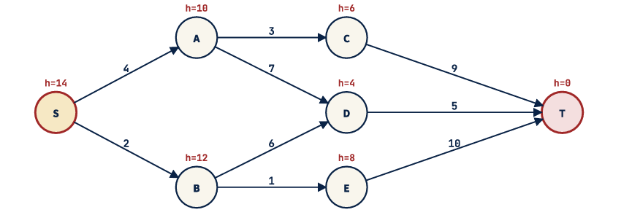
Sub-Questions
Q1: Explain how the A* search algorithm uses both actual cost and heuristic cost to find the optimal path from S to T. Discuss the role of the evaluation function:
$$f(n)=g(n)+h(n)$$
and explain why A* is more efficient than uninformed search methods like BFS and DFS in this scenario.

Q2: Using the given graph, apply the A* algorithm to find the optimal path from S to T.
Show:
- Open and closed list at each step
- Calculation of g(n), h(n), and f(n) values
- Node expansion order
- Final optimal path and total cost
Q3: Write a Python program to implement A* search for the given graph using:
- Priority queue (heapq)
- Adjacency list representation
- Heuristic dictionary
- Path reconstruction from S to T
The program should output:
- Optimal path
- Total cost
- Order of node expansion
Case Study 4: Fire Evacuation System in Forum Mall Bengaluru using A* and IDA*
A smart emergency management system is being designed for Forum South Bengaluru in Bengaluru to handle fire evacuation during emergencies. The mall contains multiple floors, food courts, cinema halls, gaming zones, escalators, emergency exits, and crowded corridors. During a fire accident, some pathways may become blocked due to smoke, fire spread, or crowd congestion.
The mall is represented as a weighted graph where:
- Nodes represent important locations such as shops, junctions, staircases, elevators, and exits.
- Edges represent walkable paths.
- Edge weights represent evacuation time or movement cost.
The emergency system must guide people from their current location to the safest exit in minimum time.
Mall Navigation Graph (Simplified)
Locations:
- S = Food Court (Start Position)
- A = Cinema Hall Corridor
- B = Gaming Zone
- C = Staircase 1
- D = Emergency Lobby
- E = Escalator Junction
- G = Main Exit Gate
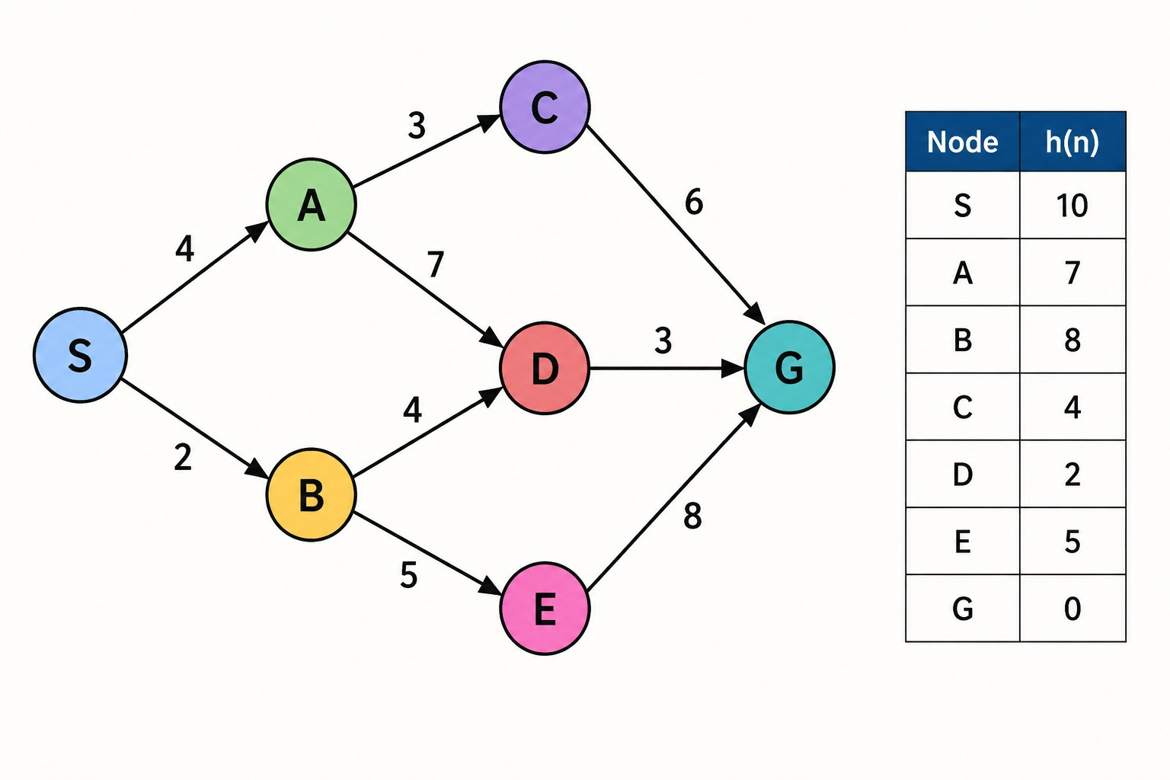
Q1: Using the A* search algorithm, determine the safest and minimum-cost evacuation path from the Food Court (S) to the Main Exit Gate (G).
- Calculation of:
  - g(n) = actual evacuation cost
  - h(n) = estimated remaining distance to exit
  - f(n) = g(n) + h(n)
$$f(n)=g(n)+h(n)$$
- Open list and closed list updates
Q2: Analyze how the IDA* (Iterative Deepening A*) algorithm can be applied to the same fire evacuation problem. Identify
- Iterative deepening mechanism
- Threshold-based search
Q3: Analyze the python program of AI-based search algorithms in real-time fire evacuation systems for large shopping malls such as Forum South Bengaluru.
- show how to represent blocked paths and dynamic obstacles
- Importance of shortest safe path computation

